How to install into eclipse

You have to copy the Class "JsonToStringBuilder.class" into your own project.

[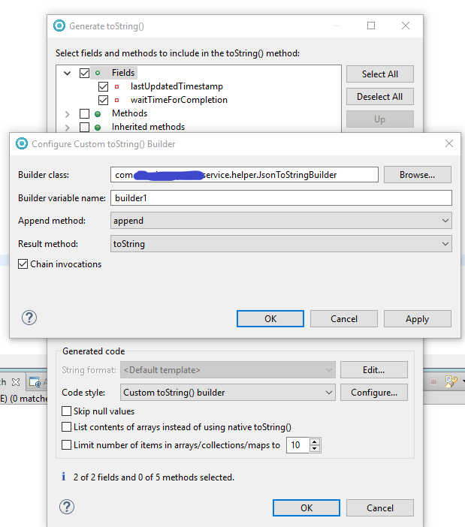](https://user-images.githubusercontent.com/26662893/61911210-c2890380-af04-11e9-97fa-614c845999eb.png)

Click OK/OK and your toString method will be nicely as below.

[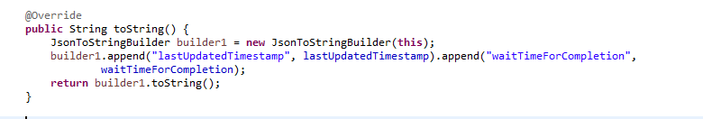](https://user-images.githubusercontent.com/26662893/61911280-0976f900-af05-11e9-9718-3b4ef3e14a10.png)

You can see the output in the log after you print the object.